10/10

* Convolution
  + 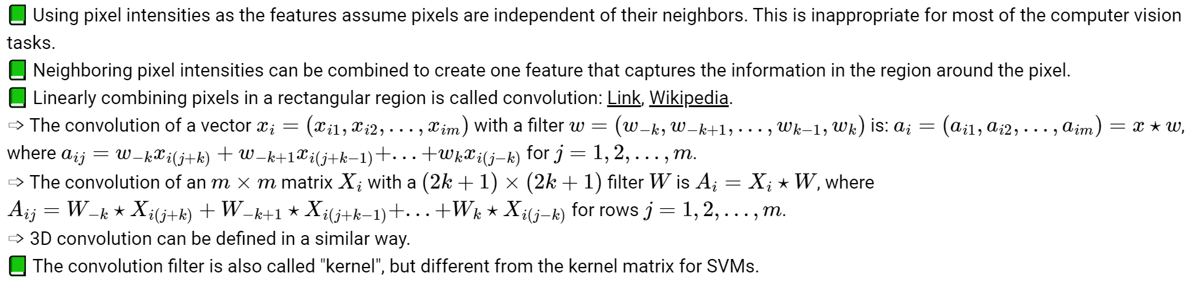
  + We add zero paddings around the image so that it is larger
  + Remember to flip the kernel before use
* Traditional computer vision algorithms
  + 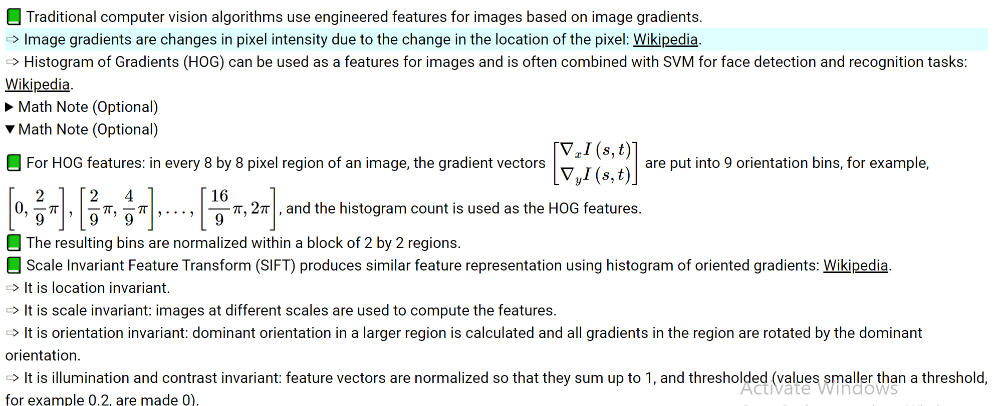
* Deep learning convolution
  + 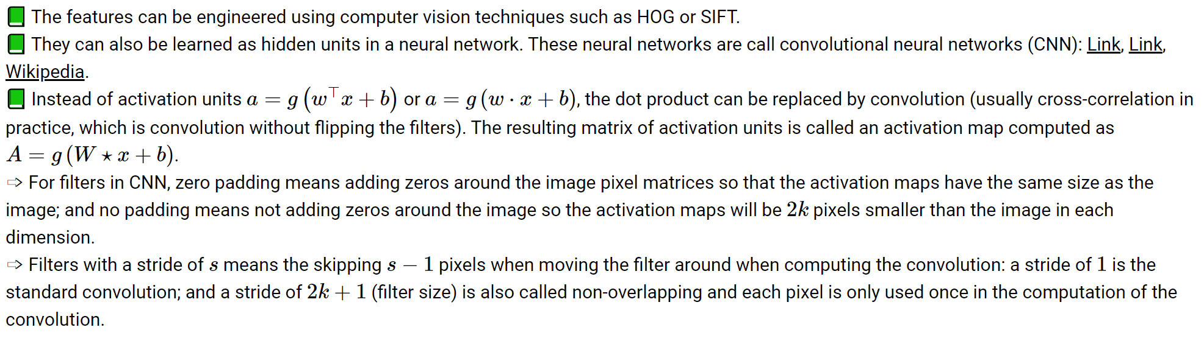
* Conv and pooling layers
  + 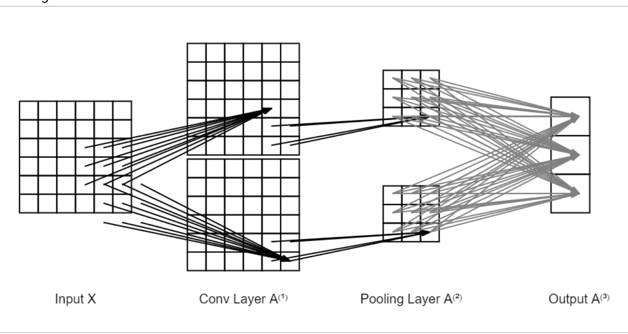
  + In the conv layer, there are 2 filters with size 3, we need to train 2 \* 3 \* 3 = 18 weights (possibly 2 biases)
  + In the pooling layer, there are 2 filters, but none of the weights need to be trained
  + In the output layer, there are 18 units in the previous layer, fully connected with 3 output units, 54 weights and 3 biases

10/17

* Google net / inception net
  + 1\*1 convolution
    - mlp on each pixel
    - Shrink the size of the output
  + Multiple softmax halfway
    - Fix vanishing gradient problem